

WebCode Reader Documentation

Instructions for the web page

Harun Hasić 170302085

# WebCode Reader Introduction

WebCode reade is a website developed by Harun Hasić for the course Web Application Development(CS412). The websites main functionality and goal is to read and translate HTML, CSS and JavaScript code and display results in the same web page. The result is an iframe that presents the new made website. WebCode Reader can be used to learn and study HTML CSS and Javascript technologies for begginers and is a great tool to help new students easily understand these basic web languages.

# WebCode Reader Description

Main WebCode reader functionality comes from the jQuery function :

$("#runButton").click(*function*(){  
 $("iframe").contents().find("html").html("<style>"+$("#cssCode").val()+"</style>"+$("#htmlCode").val());  
 document.getElementById("resultFrame").contentWindow.*eval*($("#jsCode").val());

This fuction takes the html, css and js code and translates it using it's functions and stores the result into a iframe.

# WebCode Reader Instructions

WebCode Reader has the abilit to toggle between HTML CSS and JS. This means that you can develop with ease because You can hide your CSS or HTML or JS so that you can focus on one of the parts of your website. Following are instructions on how to use the website.

### HTML

To write Your HTML code, toggle the „HTML“ button and write Your code in the window desiganted for HTML. Using classes and ids is recommended and You should always try to use them.

Example:

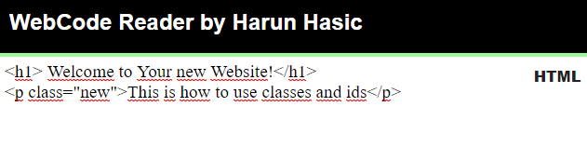

### CSS

To write Your CSS code that will respond to your HTML code, use the CSS window on the website. To toggle it, choose „ CSS“ button and then write code. If You want to apply some CSS to the entire webpage, write html{ *code goes here*}. For applying code to certain classes and ids, write Your css outside the html{} tag.

Example:

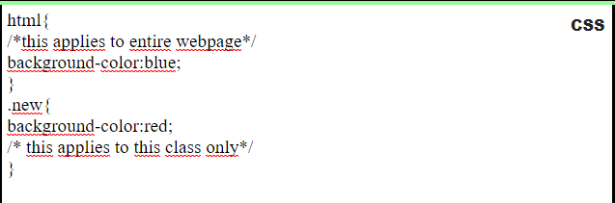

### JavaScript

To write JavaScript Code, toggle the JS button and then you can use the JavaScript window for the code. Here is an example. We will change this HTML code with a javascript function.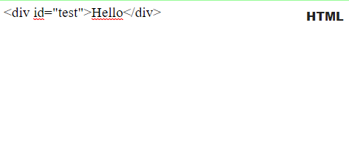

Now we will enter javascript to change the „test“ div contents. 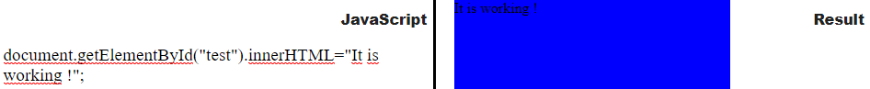

This is the result.

When You write any code, You need to click on the „Run“ button in order for the code to be displayed and ran. To choose between the different languages, use the languages button on the middle. Here are all the buttons.

This is all the documentation and the instructions to the website. Happy coding!

Contents

WebCode Reader Introduction 2

WebCode Reader Description 2

WebCode Reader Instructions 2

HTML 2

CSS 3

JavaScript 3